
QUALITY ALERT

Customer: Seaway Date: June 26, 2024
Die: 15352 Colour: All
Type of Complaint: Customer COMPLAINED

Q.A # Q.I.R # CUSTOMER NCR #

Description: Customer COMPLAINED material due to nip is undersized.
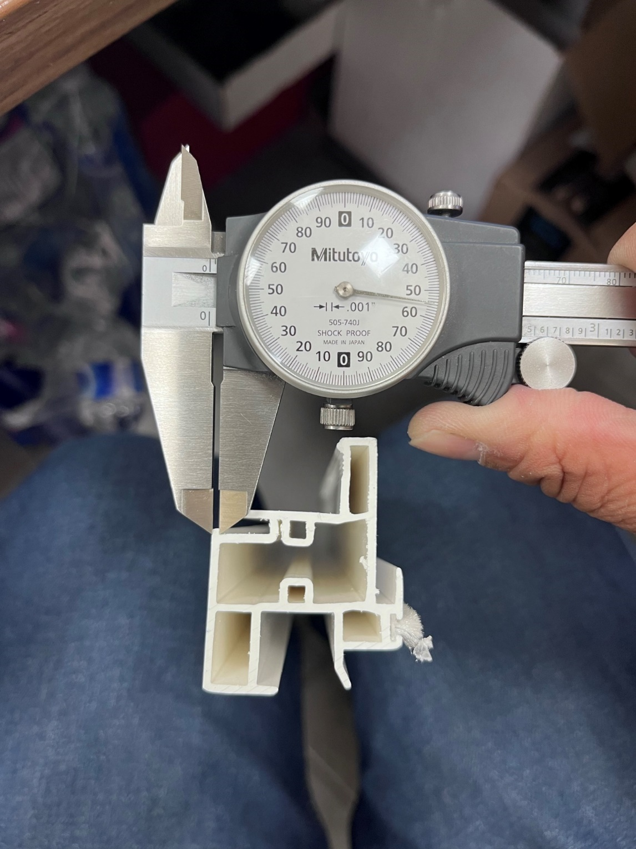
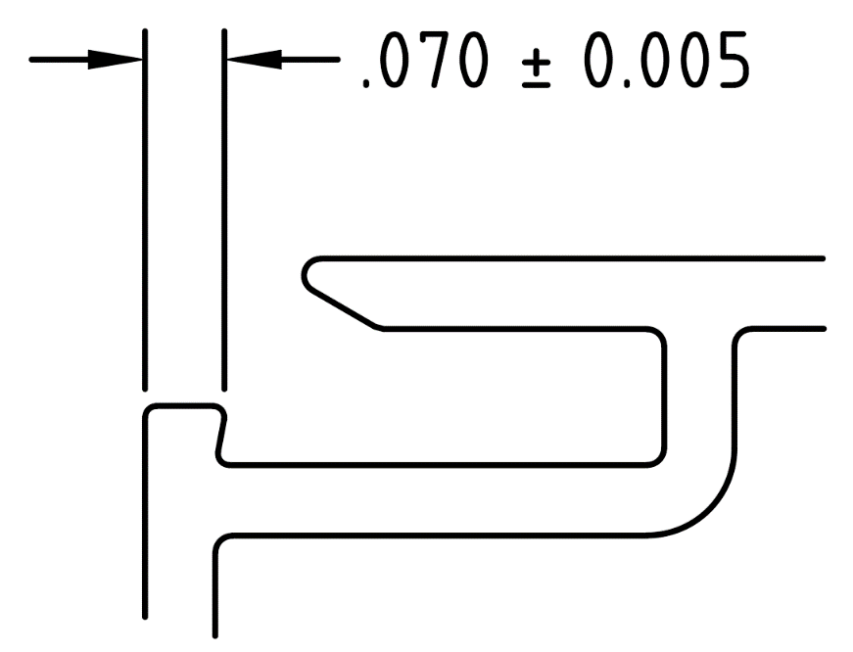

PLEASE MAKE SURE NIP IS NOT OUT OF TOLERANCE
BY SIGNING BELOW, YOU ACKNOWLEDGE THE PROBLEM ABOVE AND AGREE TO MONITOR THIS ISSUE IN FUTURE PRODUCTION RUNS.
DAY SHIFT |  | AFTERNOON SHIFT |  | NIGHT SHIFT
NAME | SIGNATURE | NAME | SIGNATURE | NAME | SIGNATURE

